**cd command:**

cd command in linux known as change directory command. It is used to change current working directory.

* **cd [directory_name]**

cd /: this command is used to change directory to the root directory, the root directory is the first directory in your filesystem hierarchy.

* **cd /**

This command is used to move inside a directory from a directory

* **cd dir_1/dir_2/dir_3**

this command is used to change directory to the home directory.

* **cd ~ or cd**

this command is used to move to the parent directory of current directory, or the directory one level up from the current directory. “..” represents parent directory.

* **cd ..**

This command is used to navigate to a directory with white spaces.Instead of using double quotes we can use single quotes then also this command will work.

* **cd "dir name"**
* **or**
* **cd dir\ name**
* **cd Code\ and\ Unit\ Testing/**

Switch back to previous directory where you are working earlier.

* **cd –**

Show last working directory from where we moved (use ‘–‘ switch) as shown.

* **cd - -**

Move two directory up from where you are now.

* **cd ../..**

Navigate from your current working directory to /etc/v__ _, Oops! You forgot the name of directory and not supposed to use TAB.

* **cd /etc/v\***

You need to navigate to user ‘av‘ (not sure if it is avi or avt) home directory, without using TAB.

* **cd /home/av?**

Change from current working directory to Downloads and list all its settings in one go.

* **cd ~/Downloads && ls**

create a directory and cd into it using a single command

* **mkdir [dir-name] && cd $_**
* **mkdir howtoforge && cd $_**

**pushd & popd commands:**

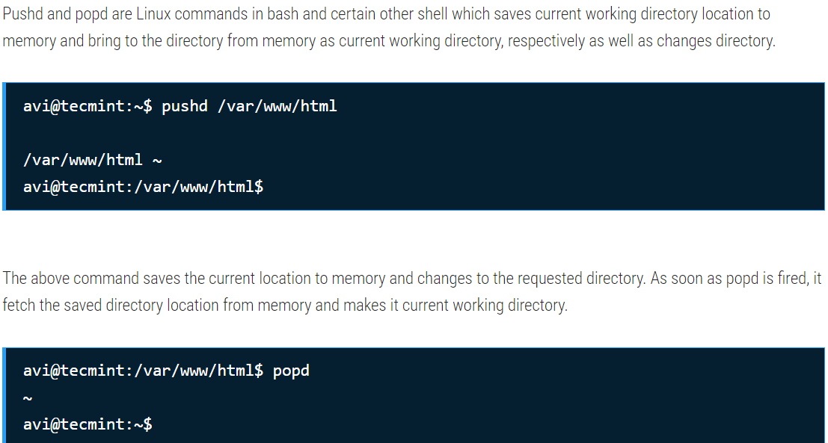

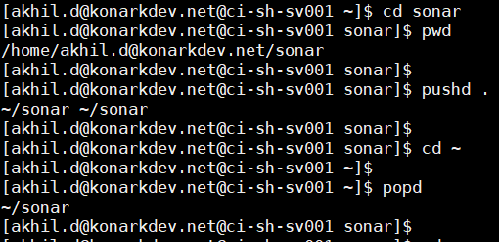

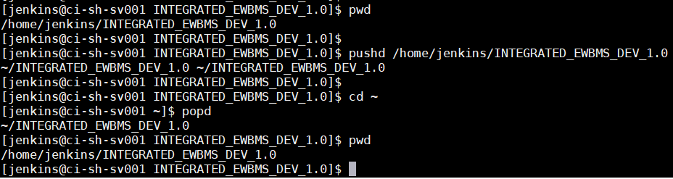

**CDPATH:**

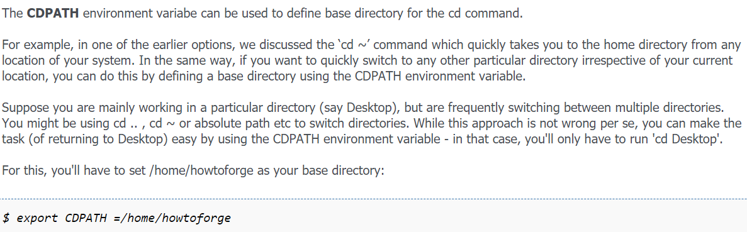

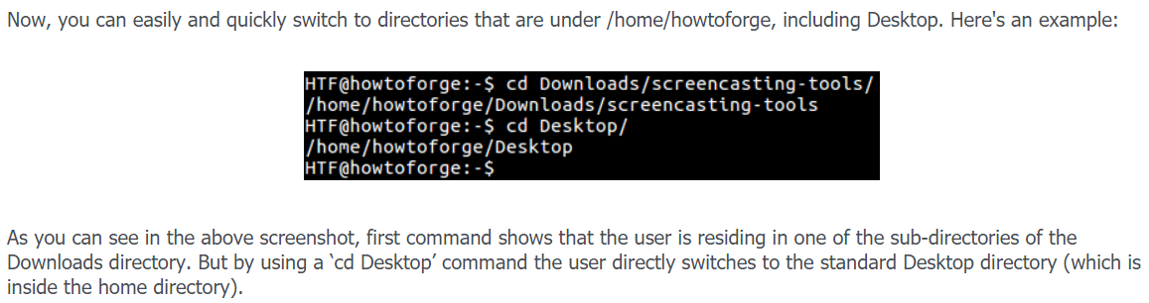

**Nick name to a directory:**

